Urinary and Digestion Worksheet
Name:

1) List the 4 stages of food processing in order
A: Ingestion
B: Digestion
C: Absorption
D: Elimination

2) Peristalsis is the smooth muscles contractions that move from mouth to anus

3) Most organisms have 2 openings, a mouth and an anus, these are said to have an alimentary canal where as animals with one opening has a gastro vascular canal.

4) Water is mainly absorbed in the large intestine.

5) Amylase is an enzyme that breaks down carbohydrates. Where does this occur? Mouth

6) The duodenum is the part of the small intestine that is still digesting chime.

7) The jejunum and the ilium of the small intestine are responsible for absorbing nutrients.

8) Mineral are an inorganic substance that living things need in order to process food and make new material.

9) Vitamins are organic substances that living things need in order to process food and make new material.

10) The renal artery carries dirty blood to the kidneys where as renal vein carries clean blood back to heart.

11) A is an essential nutrient if we cannot make.

12) The mouth and the tongue form a bolus and that is passed down the esophagus through the esophageal sphincter to the stomach.

13) Carbohydrates are broken down faster where as fats and oils break down slower.

14) Label the following pictures and give the function. Picture one is digestive system and picture two is urinary system.
Word Bank
Alimentary canal Gastro Vascular Canal Large Intestine (2) Ilium (2) Mineral
Amylase Duodenum (2) Jejunum (2) Bolus Esophagus (2)
Anus Inferior Vena Cava Aorta Kidney Slower
Digestion Absorption Renal Artery (2) Renal Vein (2) Essential
Digestive Urinary Mouth Pharynx Esophageal Sphincter Stomach Pyloric Sphincter Iliatic Sphincter Peristalsis
Fast Elimination Cecum Colon Rectum
Liver Pancreas Gallbladder Appendix Ureters
Bladder Urethra Vitamins Ingestion
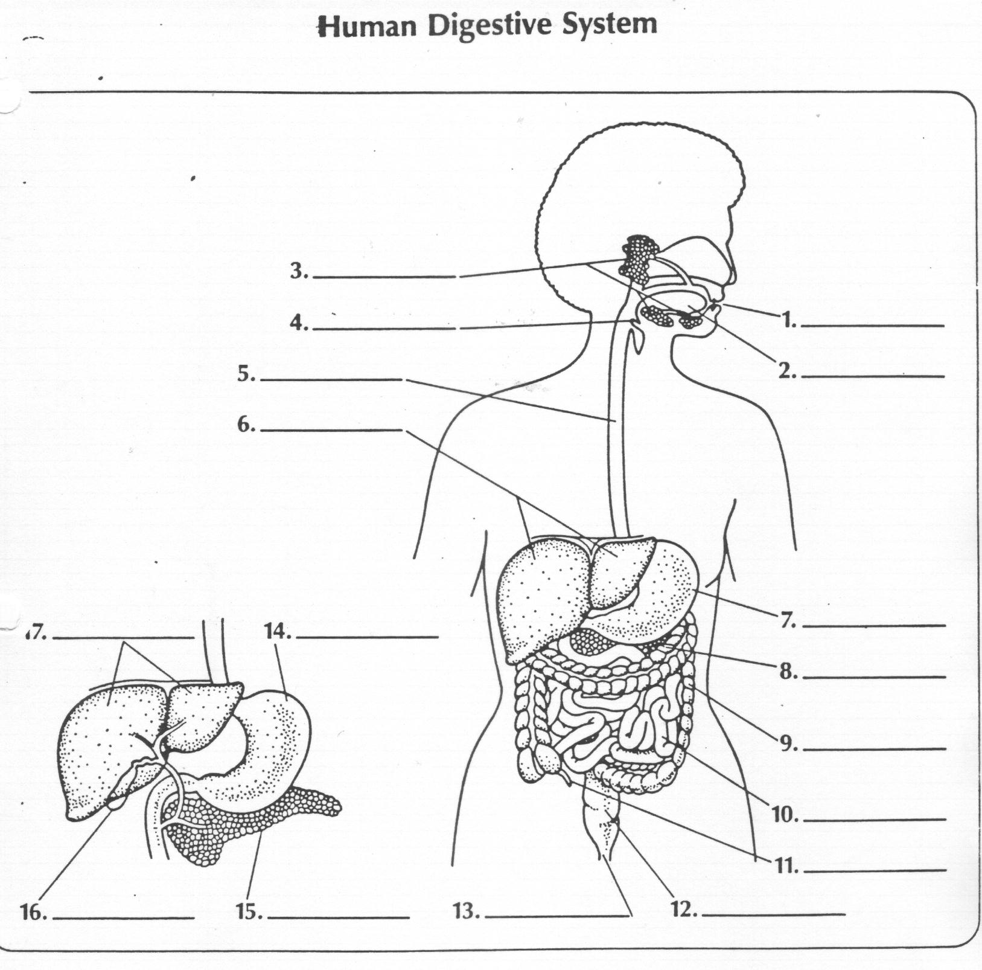
1) Mouth 2) Pharynx 4) Epiglottis
5) Esophagus 6)Liver 7) Stomach
8) Pancreas 9)Large Intestine
10)Small Intestine 11) Appendix
12)Rectum 13) Anus 14) Stomach
15)Pancreas 16)Gallbladder
17)Liver
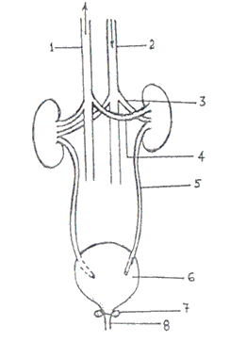
1) Inferior Vena Cava
2) Aorta
3) Renal Vein
4) Renal Artery
5) Ureters
6) Bladder
8) Urethra
Unnumbered-Kideneys

