Sensory Organs
Instructions: Using the notes on Canvas, please fill in the blanks and visit the following websites.

Human Eye:
When looking at the human eye, the first this we usually notice is going to be color of the _________. In the middle of the iris is the pupil. The pupil is an actual _________ in the center of the iris that allows ______ to enter into the eye. The light is filtered through the _______ which helps to focus images onto the retina. The _______ is made up of photoreceptors named cones and rods and is located at the back of the eye. Cones interpret _______ and rods interpret ___________ intensity. All eyes have a portion of the eye that cannot detect light called the _________. The eye has a protective clear layer called the __________ which stays moist thanks to the ______________, a thing mucous membrane that helps keep the outside of the eye moist.
Some people cannot see things up close but can see far away objects. These people are said to be _________. _____________ is the opposite, people can see at short distances but cannot see things far away. If your lens or cornea is misshapen, you might be diagnosed with ____________.
Go to the following site. Follow it through and take quiz at the end.
http://www.childrensuniversity.manchester.ac.uk/media/services/thechildrensuniversityofmanchester/flash/eye.swf
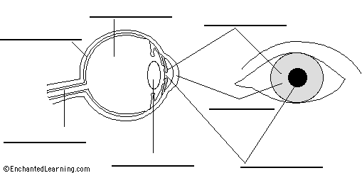

Human Hearing:
The human ear is divided into 3 main sections. The ________ ear is made up of the ______ or ear flap. The bigger the ear flap, the better you can hear. Sound then travels down the __________ canal where it is funneled toward the ________ initiating vibrations. Now we are in the ____________ ear. There are three tiny bones in the ear, the ________, _________, and __________. The last section of the middle ear is the ________________ tube. This tube connects the pharynx that equalizes pressure between the middle ear and the atmosphere. The inner ear has _________ filled channels in the ________. The cochlea has ________ that bend and send messages to the brain. The ___________________ lie next to the cochlea and can detect changes in the heads rotation or movement due to gravity (balance).
What causes motion sickness? ___________________________________________________________
List 5 reasons why we could be deaf according to the notes?
- ____________
- ____________
- ____________
- ____________
- ____________
Go to the following site. Follow it through and take the quiz at the end.
http://www.childrensuniversity.manchester.ac.uk/media/services/thechildrensuniversityofmanchester/flash/ear.swf

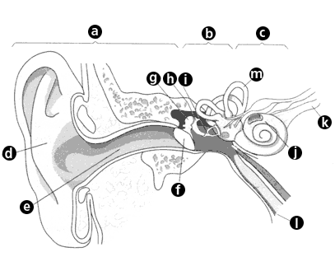

Taste and Smell
Both taste and smell are connected with the pharynx. _________________ work in our nose to detect airborne molecules and _______________ work on our tongue to detect molecules in solutions. In our nose we have ______ (little hairs) that airborne molecules bind to thus triggering an ________ potential which our brain will interpret. Tasting molecules is very similar. On our tongue, we again have _____(little hairs) that allow particles to bind to them and then the action potential is sent to the brain to be interpreted.
Go to the following website and perform the tasks.
http://www.childrensuniversity.manchester.ac.uk/media/services/thechildrensuniversityofmanchester/flash/taste.swf
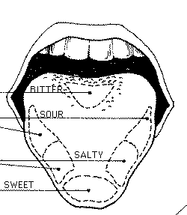
Skin – Touch
Skin can detect hot, cold, pain, and pressure. All animals have ______ receptors. Humans are covered in pain receptors except for the _________. _______________ can detect hot or cold. Our _______________ is the body’s thermostat to help trigger temperature fluctuations and regulate them. If we are cold, are our pores open or closed? ________________ . Lastly __________________ allow for us to feel touch and pressure.
Go to the following website and perform the tasks. http://www.childrensuniversity.manchester.ac.uk/media/services/thechildrensuniversityofmanchester/flash/sensitivity.swf

