Study Guide Biology 2 CP Final Exam

Ecology and Behavior
- List an example of imprinting.
- List an example of habituation.
- List an example of cognitive thinking.
- Opossums sleep during the day and are awake at night because of their kind of ____________ _____________.
- ____________ is a biome on Earth that is dominated by lichen and mosses in the summer.
- ____________ is a biome on Earth that is dominated by year around warm temperatures and high rain fall and high biodiversity.
- List 3 biotic factors.

Overview of Tissues
- Sketch the 3 types of muscle. Label them and determine if voluntary or involuntary
- The process of motion is reliant upon the _________________, _______________ and ____________________ system.
- What specific type of tissue holds together bone to bone? (CFLABB)
- What system is made of mostly smooth tissue?
- Draw simple squamous tissue and simple cuboidal tissue. Which one secretes?
- Put the following in order from the smallest to the largest. Organ, cell, tissue, system, body.
- What is homeostasis? How is negative feedback a part of homeostasis?

Reproductive, Nervous and Endocrine System
- ___________________ and _____________________ are two types of hormones. ____________ asks permission from the cell and ______________ enters the cell and manipulated the DNA.
- _______________ is the master gland.
- The _________ is a series of monthly changes in the reproductive system that includes producing and releasing an egg and preparing the uterus to receive it.
- When immature sperm leave the testes, they travel through a duct to a long, coiled tube known as the _____ where they mature and remain until expelled or reabsorbed.
- The ________________ contains the brain and spinal cord.
- The _________ ____________ increases the rate at which messages can travel through the neuron.
- Nerves cells are ___________ meaning that they can live forever!
- List function and location produced with the following hormones
  - Melatonin
  - Estrogen
  - TSH
  - Testosterone
  - Insulin
Cardiovascular System
- ________________ is the lower chamber of the heart.
- When Erythrocytes are mature, they don't have a ___________________.
- The center of some bones has red marrow and they produce _____________________, some middle of the bones has yellow marrow and make _____________________.
- ______________________ is the iron containing protein that pick up oxygen after it enters the blood vessels in the lungs.
- _______________ is(are) the grape like structures in the lungs where exchange of oxygen and carbon dioxide takes place.
- What color is the pulmonary vein?
- ________________ is a vessel that carried blood from the left ventricle to all of the body cells.
- What is the shape of your diaphragm when you inhale?
- Arteries are usually ___________(color) and usually carry blood ____________ from the body.
Digestive
- The liver makes ___________ which is stored in the gallbladder.

Muscle, Bone, and Integumentary System
- What is the thin outer layer of dead skin cells called? _____________
- When a muscle contracts, ___________ filaments pull against the moveable ____________ filaments shortening the ______________.
- Bones can get a ___________ ________________, or a small break from continued use.
- _______________ is exercise when oxygen is needed.

Bacteria, Immune, and Viruses
- Bacteria and Archea are __________, having no membrane bound nucleus or other organelles.
- Bacteria have the ability to mutate quickly because they carry extra DNA in the form of a __________.
- Breastfed babies get a _____________ immunity.
- A person who receives a donor lung may need immunosuppressive drugs so that the organ is not rejected. That person’s body might realize that the new organ is foreign due to its _______________.
- MS is a ____________ disorder.
- What type of fevers increases the maturation rate of WBC?
- __________________ is released during an inflammatory response allowing blood vessels to become leakier.
- _____________ are gram negative and have lipids that make up their cell membrane and parts of the cell wall.
Taxonomy
- How can you tell, by looking at the binomial nomenclature of two species, if they are closely related?
- _________________ is the study of the classification of living things.
- All animals are (list 3 things) __________________, _____________________, __________________________.

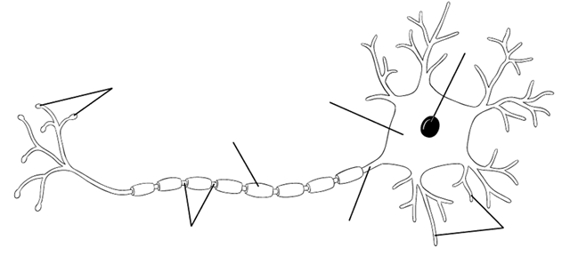 | 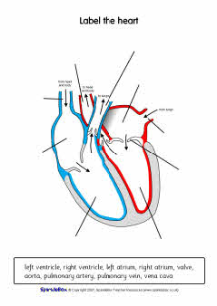
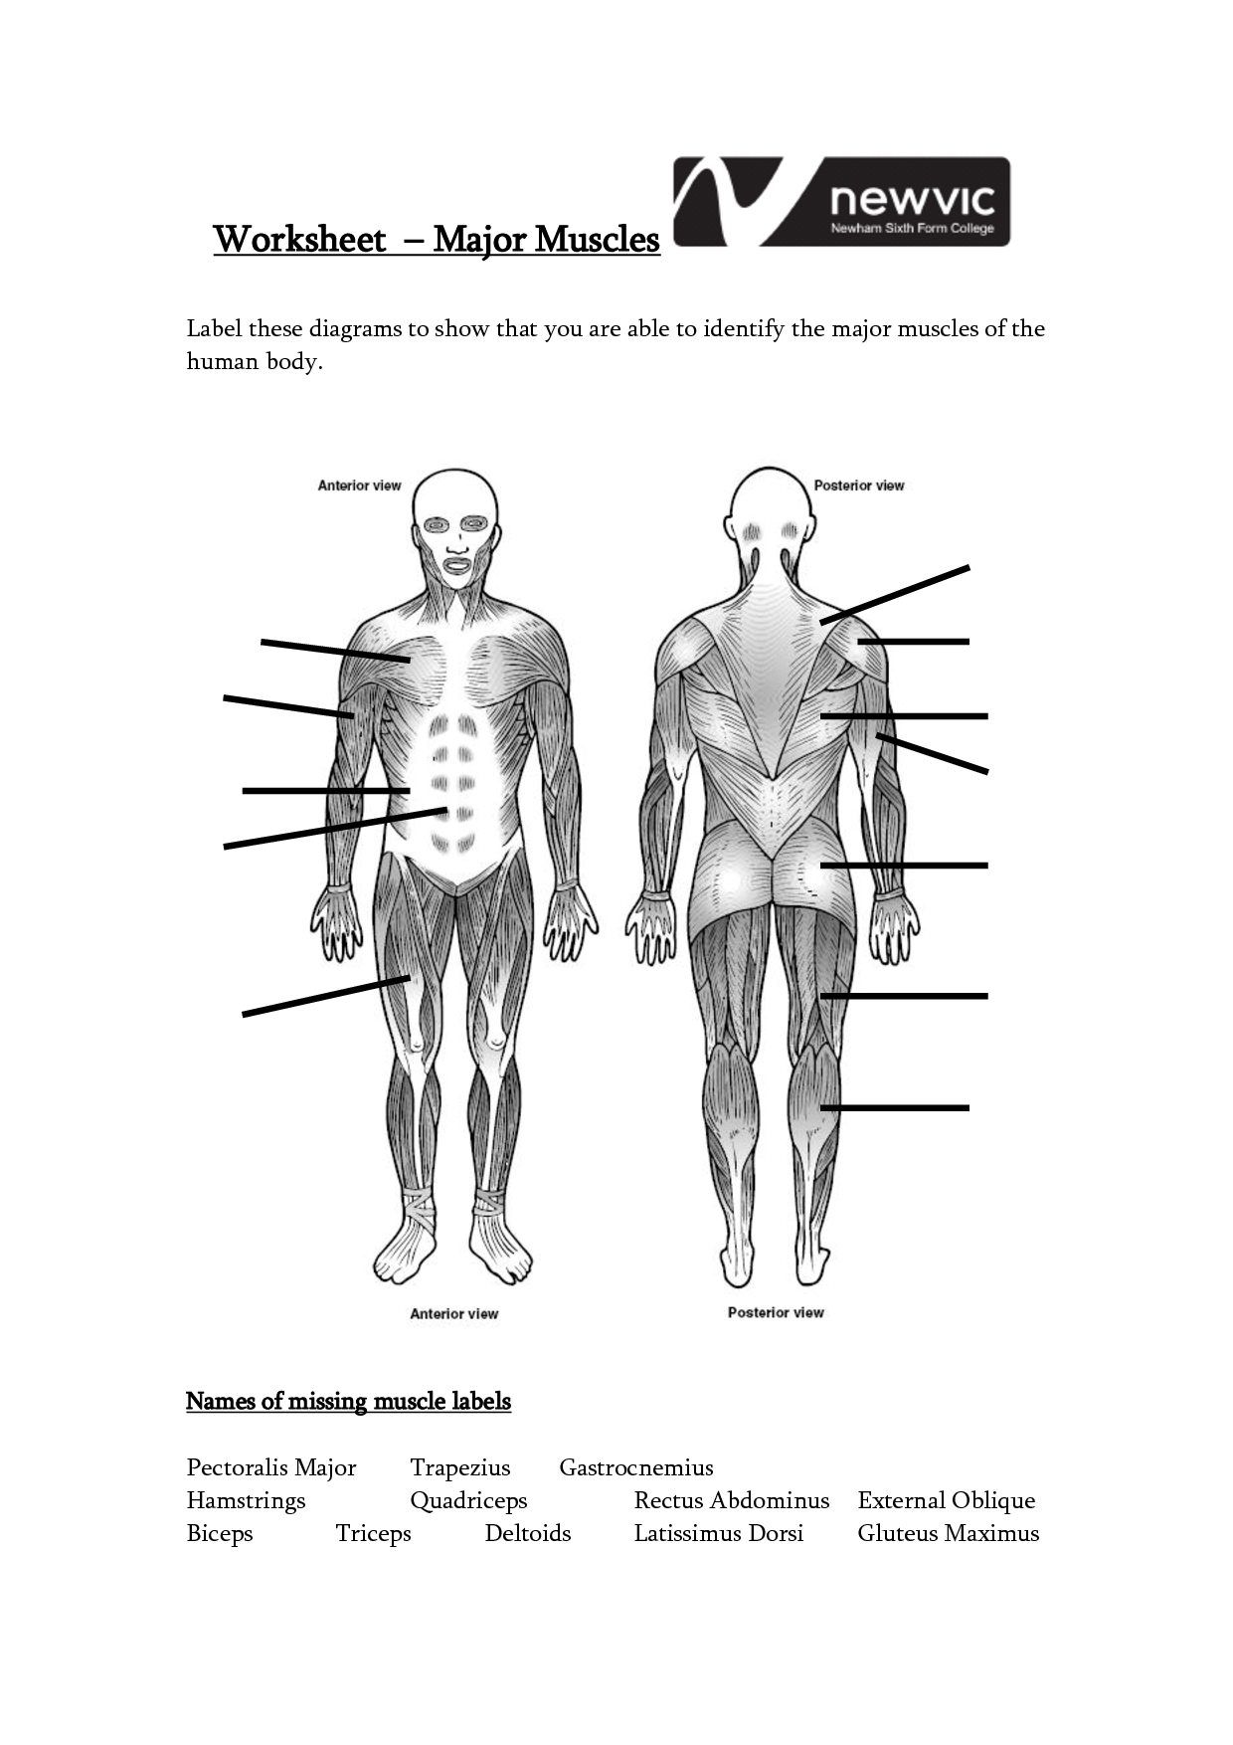 | 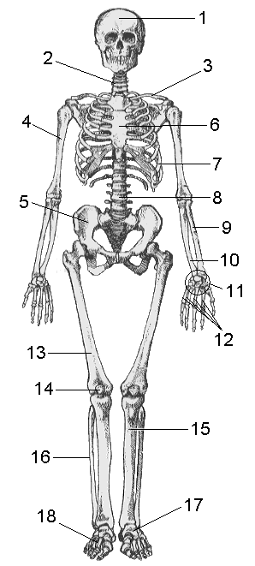
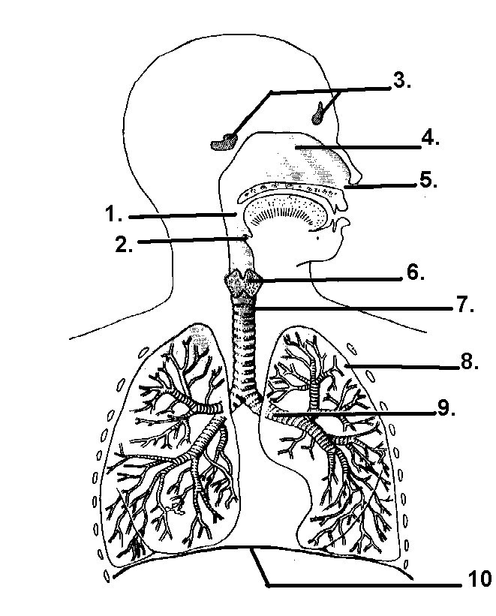 | 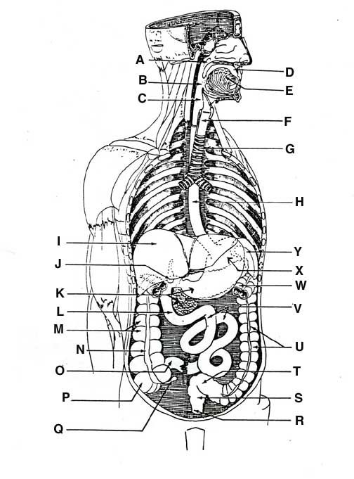
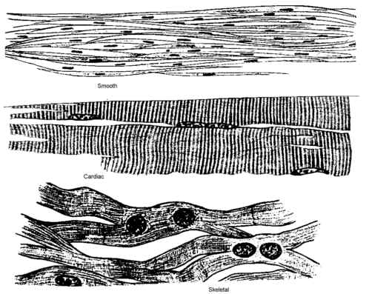 | 