Midterm CP Review

Overview of Tissues
- List the 4 major tissue types in animals.
  - Nervous
  - Connective
  - Muscle
  - Epithelial

- List the 6 types of connective tissue.
  - Cartilage, Fibrous, loose, adipose, bone, blood
- List the 3 types of muscle. Skeletal, smooth, cardiac
- What are specialized cells? Cells specialized for a specific function. Skin, bone, muscle. What did they originate from? Stem Cell
- Tissue that covers all internal and external surfaces of organs is called epithelial.
- Blood, bone, and cartilage are examples of connective tissue.
- What is homeostasis? Maintain internal conditions
- What type of tissue makes up our tendons and ligaments? Fibrous Connective Tissue
_________________________________________________________________
Nervous and Endocrine

- What is the difference between the peripheral and central nervous system? CNS is the brain and spinal cord Peripheral is arms, legs and everything else.
- How is a reflex arch different than a normal nerve transmission? Relfex arch skips going to the brain for interpretation.
- What organ has no pain receptors? Brain
- At rest, a nerve cell has more potassium (K) inside and more Sodium Na the axon of the nerve.
- Chemorecptors is a type of sensory receptors we have in our mouth and nose.
- What types of cells in our eyes interpret color? Cones Interpret light intensity? Rods
- What is the main difference between the nervous system and endocrine system? Nervous is immediate and endocrine can take seconds or minutes to start to work.
- Steroid hormones are able to bust into a cell and demand a cell to make a specific protein needed and are made up of lipids
- Non-Steroid hormones are primarily made from protein components like amino acids.
- In order for serotonin and dopamine to be released, Calcium has to be absorbed into the axon terminal.
- Multiple Sclerosis is a disorder where the myelin sheath deteriorates abnormally fast.

Hormone | Function | Location Made
- Growth Hormone | - Stimulates Growth | - Pituitary
- Lutenizing Hormone | - Stimulates Ovaries and testis | - Pituitary
- Insulin | - Decreases glucose levels in the blood | Pancreas
- Glucagon | - Increases glucose levels in the blood | - Pancreas
- Parathyroid Hormone | - Increases the Ca level in the blood | - Parathyroid
- Calcitonin | - Decreases the Ca Levels in the blood | - Thyroid
- Epinephrine | - Fight or Flight | - Adrenal Gland
- estrogen | - stimulates uterus | 35. ovaries
- melatonin | - Interprets day and night | pinal

- What is the purpose of menopause? To prevent women from getting pregnant later on in life when pregnancy could actually harm the female.
- What is the pituitary and why it so important? Master Gland, controls most other glands and what they secrete.
- Asexual is the creation of offspring whose genes all come from one parent, without the fusion of egg and sperm.
- What are the 3 phases of the female reproductive system and what occurs in each? Flow - shedding of the lining, Follicular – ovulation Luteal – prepping for pregnancy
- Once a female is born, she will have all of the _________ she will ever have.
- What is the proper pathway for gas exchange? Breathing, transport, exchange of gases with body cells
- When an egg is fertilized in the fallopian tube, the egg will then begin to divide and travel to the uterus.
- What are the 3 layers of a blastocyst?
Endoderm, Ectoderm, Mesoderm. Endoderm turns into the gut and digestive system. Ectoderm eventually turns into nerves and skin, and the Mesoderm turns into muscle.
- What is the purpose of different glands in the male reproductive system? To add fluids to help the sperm survive.
- What is diabetes? Insulin is not correct How does it harm our bodies?

______________________________________________________________

Circulation and Respiratory system
- Starting with the Vena Cava, list the pathway of blood into and out of the heart. Include Valves.
  - Vena cava, Right atrium, tricuspid valve, right ventricle, pulmonary artery, lungs, pulmonary vein, left atrium, mitral valve, left ventricle, aortic valve, aorta, body
- Arteries carry blood Away from the heart and Veins carry blood toward the heart.
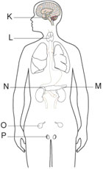
- What type of blood cell carries Oxygen and Carbon Dioxide? Red Blood Cells, Eurythrocytes What type prevents infection? White blood cells, Leukocytes
- The Coronary artery supplies the heart with oxygen. If this artery is clogged with plaque, it can cause a Heart Attack.
- Epiglottis is a flap of muscle that prevents water and food from entering our trachea.
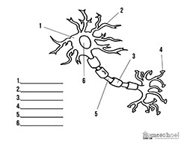

K – pituitary
L – Thyroid
N – Adrenal
M – Pancreas
O – Ovaries
P - testes

1. Cell body, 2. Dentrite, 3. Schwann Cell, 4. Axon, 5. Nodes of Ranvier, 6. Nucleus
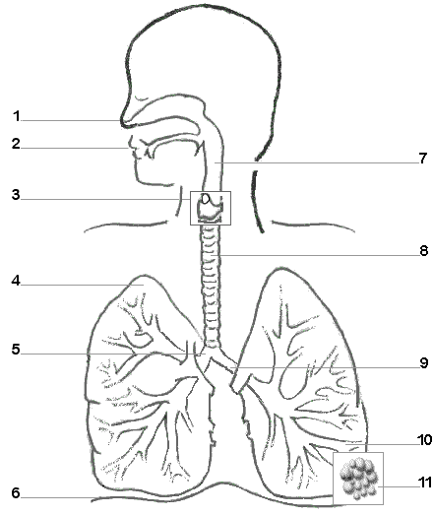
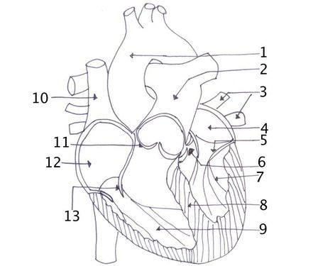
1. Aorta 11. Pulmonary valve 1. Nasal Passageway 9. Bronchi
2. Pulmonary Artery 12. Right Atrium 2. Mouth 10. Bronchiole
3. Pulmonary Vein 13. Tricuspid 3. Layrnx 11. Alveoli
4. Left Ventricle 4. Lung
5. Mitral 5. Bronchi
6. Aortic Valve 6. Diaphram
7. Left Ventricle 7. Pharynx
8. Septum 8. trachea
9. Right Ventricle
10. Vena Cava

